Hild of Wessex, Incantations, Entrails, and Chicken Blood: Draft 2019

“The future is unknown, and the end is always near.” -James D. Morrison (*indicates underclassman)
As we get ready to kick off the 2018 PAFL football season, our team of draft analysts and experts have been hard at work all offseason, watching film and dissecting our wealth of data on every snap of FBS action since 2014 to outline the nation’s top prospects who could hear their names called next April in the PAFL. Naturally, we are limiting are shared insights and visions to only the top players, we cannot spill all the bones!
However, we will tell you with confidence that defensive linemen will be the story of the class. A loaded group of defensive linemen will overwhelm the first round of next year's draft, as our top four prospects for next season all play the defensive line. Hild of Wessex stated, “so it shall be done, so it shall be written.”
Here, deep in the Viking Longhouse of Ragnar, we can't help but look ahead, and we have the top 19 PAFL Draft prospects for 2019 on our radar. Here are the star college football players that are bound to move up and down on the war room boards of every PAFL franchise.

Draft 2019: Next year's best prospects
(*indicates underclassman)
1. Ed Oliver*, DT, Houston 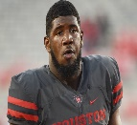
Oliver declared his eligibility for the 2019 NFL Draft in spring practice. That's out of the way, so expect Oliver to continue making his case to be the No. 1 overall pick. There will be some nitpicking, but the truth is he's one of the few outliers who was ready for the NFL two years ago. Oliver will have some serious competition from the next three defensive linemen on this list. If Oliver goes No. 1 overall in the 2019 NFL draft, he will be the second defensive lineman to be selected with the top pick in three years, joining Cleveland Browns defensive end Myles Garrett, who went No. 1 in 2017.
2. Nick Bosa*, DE, Ohio State 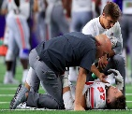
True, he left Ohio State due to injury and he is a Buckeye, but to date, the nearest comparison remains his older brother Joey (without the foot), who totaled 12.5 sacks in his second season with the Chargers in 2017. Nick Bosa continues to carve his own niche as a dominant edge rusher for the Buckeyes. He totaled 8.5 sacks and 16 tackles for loss last season. The junior All-American from Fort Lauderdale, Florida, already had four sacks this season when he suffered a core muscle injury Sept. 15 in the third game of the season. He had surgery five days later, and no timetable was set for his return to the team. Scout's Quote: "I love Nick Bosa. I wasn't 100 percent sure on Joey coming out (stupid me), but I won't make that mistake twice. He's the real deal. Excellent instincts and feel for the quarterback as a young rusher." He will challenge Oliver for the top spot, and it's closer than you think.
3. Dexter Lawrence*, DT, Clemson 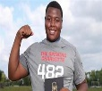
Lawrence, a 6-5, 340-pound defensive tackle, would have a been a top-five pick this year had he declared. He might have been a top-five pick in 2017, too. He's part of that awesome Clemson defensive line juggernaut, and despite a drop in statistical production last season, not much else has changed. Great size and excellent disruptor in the run game, as he’s able to jack up blockers and deter running backs. Can push the pocket and rush the passer, ranking third among FBS defensive tackles with a pass rush productivity of 11.8 in 2016.
4. Rashan Gary*, DE, Michigan 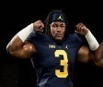
Gary, the former No. 1 recruit in the nation, totaled 58 tackles, 11.5 tackles for loss and 5.5 sacks in his first season as a starter. A physical tour de force whose capable of playing through or around offensive linemen. Another year in Don Brown's defense should produce even better numbers, and Gary must get a few more sacks if he wants to compete with the other three linemen ahead of him. It can be done. GO BIG BLUE!!!!!
5. Will Grier, QB, West Virginia 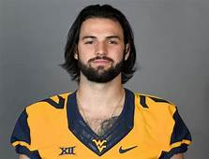
Grier's career path has taken a few interesting turns, but he showed in his first full season with the Mountaineers how much talent is there. There's a big arm, mobility and high-volume statistics. He passed for 34 TDs with just 12 interceptions and averaged 9.0 yards per attempt. Confident thrower down the seams and over the top of the defense, posted the most big-time throws on 20-plus yard passes in 2017. Shows the poise to hang in the pocket and work through multiple reads. He's good enough to be a top-five pick if that development continues.
6. A.J. Brown*, WR, Ole Miss 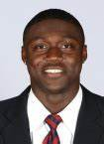
Brown enjoyed a monster sophomore season in which he averaged 16.7 yards per reception with 11 TDs. Brown (6-1, 225 pounds) is a strong receiver, excellent route runner and down-field threat. He also decided to stay at Ole Miss instead of transferring. Big-bodied pass-catcher with a good feel for route running in man and zone coverage. He's a top-10 talent and the best at the position.
7. Trey Adams, OT, Washington 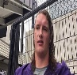
Adams (6-7, 302 pounds) is a sound tackle and could work his way into a top-five pick. Adams, however, must stay healthy after dealing with injuries the last two seasons. Scout's Quote: "He's Taylor Lewan all over again. People will overthink it and wonder if he's a left or right [tackle], but just draft him and don't worry about the left side for five years." He'll have competition from the next two tackles on this list.
8. Greg Little*, T, Ole Miss 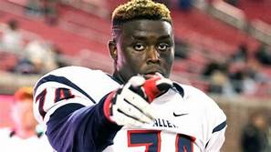
A 6-6, 325-pound tackle, Little has progressed as expected as one of the best offensive linemen in the nation. He's a big, mean, nasty SOB who probably projects best to the right side. But he's better than any of the guys from last year’s draft. He's an excellent pass blocker and will jostle with Adams and Jonah Williams to be the first tackle drafted next season.
9. Jonah Williams*, OT, Alabama 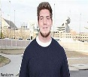
Williams (6-5, 296 pounds) has played both right and left tackle the last two seasons for the Crimson Tide, and he's handled that transition well. He allowed just 2.5 sacks last season as a sophomore. After moving to the left side in his sophomore season, Williams continued to display the tools to be a No. 1 overall pick. It will depend on team needs, but Williams could be in the conversation for the top selection. This august body hasn't seen a tackle prospect like this since the Ronnie Stanley-Laremy Tunsil draft of 2016. Williams will continue to develop as Alabama's next first-round pick.
10. Christian Wilkins, DE/DT, Clemson 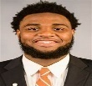
The 2017 first-team SN All-American surprised some by returning to school for one more season, and we've seen him dominate on the interior for three years. He's totaled 10.5 sacks and 26.5 tackles for loss, and his leadership continues. Wilkins has the tools to beat blocks and make plays in the running game and that’s where he’s been at his best during his three-year college career. He'll be a solid top-10 pick.
11. Deandre Baker, CB, Georgia 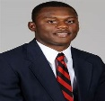
Baker is a solid tackler for the Bulldogs, and the 5-11, 180-pound defensive back has five interceptions and 14 pass breakups over the last two years. He's another multi-purpose corner NFL teams will be able to move around in the secondary. Shows the ability to stick with receivers in man coverage. Moves well and has good ball skills, leading to 10 pass breakups and three interceptions in 2017. Personally, I call this a reach at 11 but who am I to challenge the fates? SKOL
12. Clelin Ferrell*, DE, Clemson 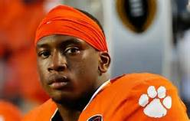
Ferrell decided to stay in school this year, and he still has one year of eligibility remaining after 2018. He won't need it. Ferrell is another force on Clemson's defensive line who has totaled 15.5 sacks and 30.5 tackles for loss the last two seasons. He's the third Clemson defensive lineman on this list. Scout's Quote: "I liked [Shaq] Lawson and [Kevin Dodd] when they were coming out, but this one is on a different level. Strength, length, burst, instincts. He has it all."
13. Raekwon Davis*, DE, Alabama 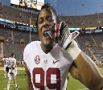
Davis enjoyed a breakout sophomore season in which he finished with 8.5 sacks and 10 tackles for loss. The competition to be a top-10 defensive lineman will be fierce, but Davis should benefit from the addition of new defensive line coach Craig Kuligowski. Ideal end in a 3-4, Raekwon Davis was exceptional off the edge in rotational duty. Can play on the inside, but his length and initial burst make him an ideal outside pass rusher. Can maintain his gaps against the run when needed, but primary skillset is using his long arms and strong lower body to use a variety of pass rush moves to win with power and speed. While generally ranked lower, we see a very successful career in the PAFL.
14. Greedy Williams*, CB, LSU 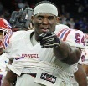
Williams is a redshirt sophomore, but the 6-2, 182-pound cornerback had six interceptions and 10 pass break-ups in 2017. Excellent size, speed and length allows him to play press-man coverage and stick with receivers in man coverage. Williams is that good that early, and he'll be tempted to go to the next level in 2019 as one of the top cornerbacks in the nation. You can’t pay for this kind of insight, book on it!
15. Jarrett Stidham*, QB, Auburn 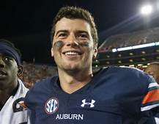
Stidham brings a live arm and solid mobility to the position, and he's worked in up-tempo offenses at Baylor and Auburn. That will be somewhat of a question mark for scouts, but he fits into the mold of successful passers such as a Jared Goff and Carson Wentz. He'll also have the big-game spotlight in the SEC. A transfer from Baylor, Stidham won an early battle for the Auburn starting QB job. Wildly inconsistent throughout the 2017 season, but came up big in his biggest games, beating the number one team in the country not once, but twice. Big strong arm. Another year in college would probably be best to continue to work on accuracy and decision-making ability. But where is Herbert you ask?
16. Bryce Love, RB, Stanford 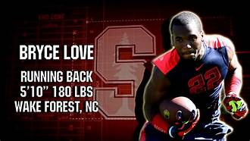
The Heisman Trophy finalist returned to school, and we can't wait to see his 40 time at the PAFL Combine. Love averages 7.8 yards per carry for his college career, and another year at Stanford will not hurt his stock. Blazing speed. There is no greater home-run threat at the position than Love, who can make one cut and be gone for a touchdown in a heartbeat. Size is a question mark but not one he can really do anything about, instead, Love needs to work on his role in the pass game, as he saw just eight targets in 2017, dropping two of them. The bones tell all. . .
17. Shea Patterson*, QB, Michigan 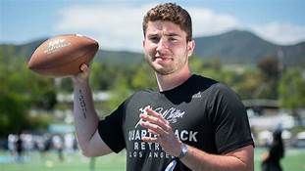
Patterson is a flashy playmaker with a cannon for an arm, but the truth is we haven't seen enough, and last year's PCL injury is a major concern. If Patterson develops in Jim Harbaugh's offense and wins big (TBD), then all those questions will be answered. Even so, the former Ole Miss starter is now the preordained savior in Ann Arbor. Patterson's ability to extend and make plays will give Jim Harbaugh's staff a weapon it has not had under center at Michigan. Wolverine faithful are hoping he's the missing piece to a Big Ten title run. I am one of them being a proud graduate (Class of ’77)! Definitely a homer pick on my part, so take care.
18. Drew Lock, QB, Missouri 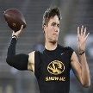
Lock (6-4, 225 pounds) led the nation with 44 TD passes last season and has improved in each season with the Tigers. The trick in Lock’s evaluation, as with many QB’s in college systems, is separating the scheme from the player. He is asked to throw more deep balls than any QB in the country which naturally hurts his completion percentage, but helps other stats. He set an SEC record for passing touchdowns in a single season with 44. If Lock continues to play like he did in the back half of the 2017 season against tough competition, then he will have a chance to move into the top 10. He's good enough to get there.
19. Rodney Anderson*, RB, Oklahoma 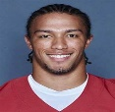
Anderson picked up where running backs Samaje Perine and Joe Mixon left off for the Sooners. Anderson averaged 6.2 yards per carry as a sophomore, and that included 201 yards in the Rose Bowl loss to Georgia. After being injured his first two seasons at Oklahoma and not being used much early in this season, Anderson has emerged as one of the most productive and dynamic running backs the second half of this season. He is a do it all back that is deadly in the open field where he can quickly change direction and get into top gear after a cut. A power back with speed, he is a weapon in the passing game with good hands and can make the catch and effortlessly transition to making yards after catch. He was briefly charged with rape, but the charges were dismissed, and he passed a lie detector test. Which as we all know means nothing, but we still rank him over Damien Harris long-term.

Disclaimer: The staff here at Ragnar’s wish everyone a very merry Halloween, why we simply do not comprehend. Stupid Druids! It should be noted that this is not a scholarly product, but it is an exercise of academic value. We openly admit that this ranking may cause some rancor and discord amongst the faithful, but Hild insists that she never used a Ouija board, no not once! Be it known that the Oracles was consulted and hence this incantation!

Sidebar: Hild of Wessex present day incarnation and she wants everyone to know they can all go pound sand! Moreover, she opines, “why won’t the gods kill Tom Brady?” We can only shake our heads as we cannot control her. We fear the death of death: invisibility! SKOL!!!!!

